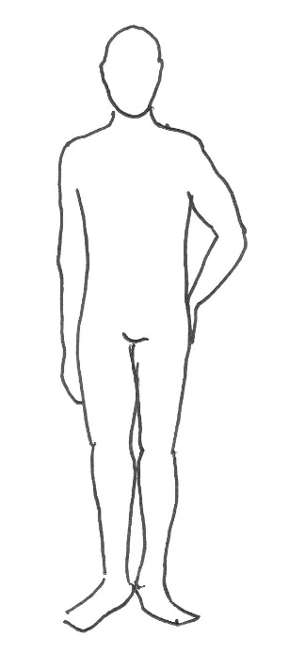
4
2
1
3
NAME

CONTACT NO.

EMAIL ADDRESS

PRODUCTION TITLE & DATES

1 | CHEST
2 | WAIST*
- | PADDED BUST**
3 | COLLAR
4 | INSIDE LEG***
5 | HEIGHT
Please be accurate and honest with all measurements.

- Measurements in inches only and provide only measured measurements.
- Do not measure in cm and convert, as this will be inaccurate.
- Please measure at the fullest part of the waist (typically across the bellybutton). *
- Only supply if wearing your own padded bra. **
- Inseam to ankle bone only (where the seam starts on a good fitting pair or trousers to the ankle bone). ***

Details of Costumes Required

Our individual Dame costumes cost between £50 and £75 + VAT per costume per week to hire ‘workers’ and some Finales.

Specialist, structured and deluxe costumes range between £80 to £175 + VAT per costume per week to hire. Carriage is an additional charge.

Please list below your requirements, number of costumes, preferred budget etc as follows e.g.
The more info we have about your requirements, the more we can do to help.

- Generic ‘Worker’ costume, food theme, up to £55 – then quick-change into…
- Naval-themed dress, approx. £45
- Songsheet – anything glam, approx. £55
- Finale, red and gold, up to £60

Please list your required costumes below

