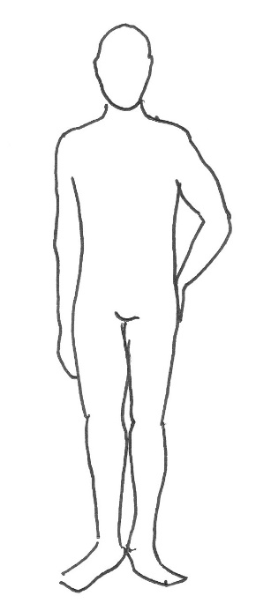
3
5
2
1
4
NAME

MOBILE NUMBER

EVENT DATE

COSTUME/S REQUIRED (send a name or screenshot)

1 | CHEST
2 | WAIST*
3 | TROUSER SIZE**
4 | COLLAR
5 | INSIDE LEG***
6 | HEIGHT
7 | SHOE
Please measure in inches only, and provide only measured measurements.
(do not measure in cm and convert, as this will be inaccurate)
* Please measure at the fullest part of the waist (typically across the bellybutton).

** This is your high street trouser size: we ask for this to show that the waist measurement (#2) is going to be more accurate. (The waist measurement will affect not only trouser fit, but also jackets and waistcoats, so is important to be correct.)

*** Inseam to ankle bone only (where the seam starts on a good fitting pair or trousers to the ankle bone). This may well be shorter than your high street trousers – this is normal.

We do not care what size our clients are; we simply want to ensure the best fit.
Please be accurate and honest with all measurements.

