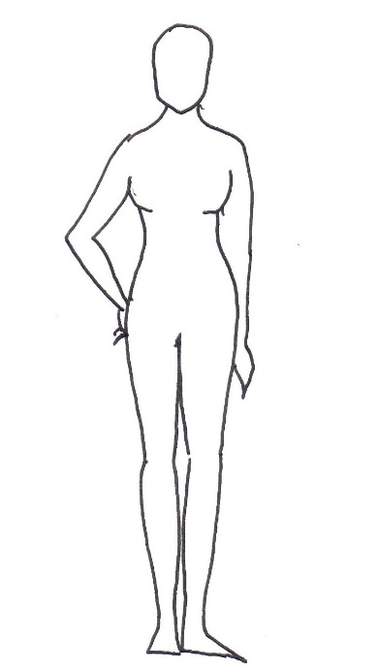
5
4
3
2
1
NAME

MOBILE NUMBER

EVENT DATE

COSTUME/S REQUIRED (send a name or screenshot)

1 | BUST
2 | UNDER BUST
3 | WAIST*
4 | HIPS
5 | INSIDE LEG**
6 | HEIGHT
7 | SHOE
Please measure in inches only
(do not measure in cm and convert, as this will be inaccurate)

* Please measure at the fullest part of the waist (typically across the bellybutton).

** Inseam to ankle bone only (where the seam starts on a good fitting pair or trousers to the ankle bone). This may well be shorter than your high street trousers – this is normal.

We do not care what size our clients are; we simply want to ensure the best fit.
Please be accurate and honest with all measurements.

